Let’s Build the Cloud, One Server at a Time!
GHC 2018 Workshop Instructions for Servers 18 - 22
Niharika mateti, RADHIKA SAKSENA, AKANKSHA GUPTA
2018

Instructions for Servers labeled 18-22

Before you begin
- In this workshop you will be removing the components of a server and assembling it back. The workshop is for 30 minutes. You can take time to explore the server, but please ensure to put back all the components inside the server and close the top cover at the end of 30 minutes.
- Please take turns around the table for each instruction.
- The round label on the top of the server shows the server model and generation. The printed instructions provided to you are for the model of the server on your desk. If you believe you may have received instructions for a different model, please bring it to the presenters’ attention.
- You may need to apply some force to snap things into place. But if you are applying too much force or if you are not able to pull the components out, then you are doing something wrong. Check the instructions and try again.
- There are volunteers around to help you if you require any assistance.
- In most cases, you will not require a screwdriver. You should be able to loosen the thumbscrews easily. But if you need one, please ask the volunteers or the presenters for one.
- Study Figure 1 to understand the system board components and their location.
- On some servers there is additional information on the bottom side of the top cover.

Removal Instructions
- Remove the top cover from the server.
- Lift the latch on the top cover.
- Slide the cover toward the rear of the server and then lift to remove the top cover from the chassis.
- Remove the air baffle. The air baffle is a plastic cover that goes over the processors and memory.
  - See Figure 4.
  - Lift the air baffle straight up and out of the chassis to remove.
- Remove the 2 RAM DIMMS.
- See Figure 2 for a picture of a DIMM.
  - Open the DIMM slot latches located at the edges.
  - Lift the DIMM up and out of the DIMM slot.
- Remove all the fans.
  - See Figure 7.
  - Grasp the fan by the finger grooves.
  - Pull the fan straight up and out of the fan cage.
- Remove the power supply. Some servers have 2 power supplies, remove both of them. The power supplies are at the back of the server.
  - See Figure 8 for a picture of the power supply.
  - Press the release tab toward the left.
  - Grasp the power supply handle and pull the power supply from the bay.
- Remove the PCI riser cage.
  - See Figure 5.
  - Loosen the three thumbscrews that secure the PCI riser cage to the server chassis.
  - Pull up on the two side release levers to disengage the PCI riser cage from the system board.
  - Lift the PCI riser up and off of the server chassis.
- Remove the PCI card from the PCI riser cage.
  - See Figure 9 for a picture of a PCI card.
  - Carefully pull out the expansion board (PCI card) out of the riser card expansion slot.
- Remove the hard drive. The hard drives are in the front of the server. There is just 1 hard drive.
  - Press the red ejector button to release the handle.
  - Use the handle to slide out the hard drive.

Installation Instructions
- Install the Fans.
- See Figure 7.
  - Grasp the fan by the finger grooves.
  - Lower the fan straight down into the fan cage until it is fully seated and clicks into place.
- Install the 2 RAM DIMMs. Check the number of processors installed in you server. If only 1 processor is installed, place the 2 DIMMs according to the alphabetic order (A and B slot for the installed processor). If 2 processors are installed, place each of the DIMMs in the A slot of each processor.
  - See Figure 2 for DIMM Installation
  - See Figure 3 for DIMM slots.
  - Ensure that the DIMM slot latches are open.
  - Locate the alignment notch on the DIMM and align it with the key in the DIMM slot.
  - Push the DIMM down firmly into the slot until the DIMM slot latches snap into place.
  - Ensure that the DIMM is fully inserted and properly seated in the slot.
- Insert the power supply into the power supply slot.
  - See Figure 8
  - Slide the hot-plug power supply into the power supply bay until it is fully seated and clicks into place.
- Install PCI expansion board into the PCI riser cage.
  - Gently push the expansion board into the riser card expansion slot. Find a slot which is empty.
  - Ensure that the PCI card is fully inserted and properly seated.
- Install the PCI riser cage.
  - Check Figure 6.
  - Lower the PCI riser down on the server chassis.
  - Push the two side release levers down to engage the PCI riser cage to the system board.
  - Tighten the three captive thumbscrews that secure the PCI riser cage to the server chassis.
- Install the hard drive into bay 1. On some servers, check the front of the server for the hard drive bay numbering. On other servers there is a label on the top of the server which shows the hard drive bays numbering.
  - Press the ejector button to release the handle.
  - With the hard drive handle extended, insert the drive into the drive bay.
  - Close the drive handle to lock the hard drive into place.
- Replace the air baffle.
  - See Figure 4.
  - Align the air baffle guide slot with the ridge on the top of the heat sink bracket and lower the air baffle into place.
- Replace the top cover.
  - To replace the top cover, align it to the chassis then slide it toward the front panel.
  - The latch should be open while sliding the cover.

DL380/DL385 Gen7 System Board Components
Figure 1: DL380/DL385 Gen7 System Board Components

Item | Description
1 | Processor 2 DIMM slots
2 | SAS power connector A
3 | SAS power connector B
4 | Front I/O connector
5 | SATA optical drive connector
6 | Internal USB connector
7 | System battery
8 | Power supply backplane connector
9 | NMI jumper
10 | System maintenance switch
11 | Processor socket 2
12 | Primary riser connector
13 | SD card slot
14 | TPM connector
15 | Processor socket 1 (populated)
16 | Processor 1 DIMM slots
17 | Secondary riser connector
18 | SAS connector A
19 | SAS connector B
20 | Cache module connector
21 | Fan connector 1
22 | Fan connector 2
23 | Fan connector 3
24 | Fan connector 4
25 | Fan connector 5
26 | Fan connector 6

Installation of a DIMM

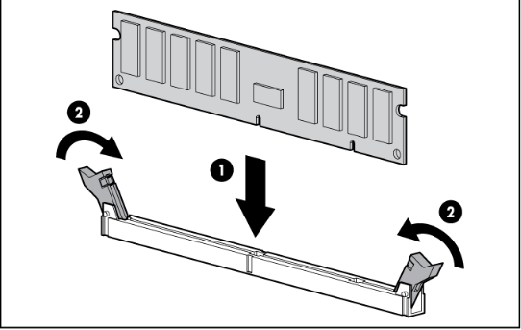
Figure 2: Install a DIMM
DL380/DL385 Gen7 DIMM Slots
Figure 3: DL380/DL385 Gen7 DIMM Slot Locations
Remove the air baffle
Figure 4: Remove Air Baffle
Remove the PCI riser cage

Figure 5: PCI riser cage removal

Install the PCI riser cage

Figure 6: PCI Riser Cage Installation

Install Fans
Figure 7: Fan installation

Power supply

Figure 8: Insert power supply

PCI
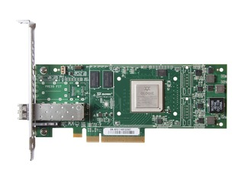
Figure 9: PCI expansion card

